**A**

**SOFTWARE REQUIREMENT SPECIFICATION**

**ON**

**ONLINE VOTER REGISTERATION SYSTEM**

**UNDER**

**NON SYLLABUS PROJECT**



**Submitted To: Submitted By:**

**MR. PUNIT KUMAWAT PULKIT MITTAL (PGI20AD010)**

**(PROFESSOR) YASH NAGLA (PGI20AD013)**

**LAKSHYA BHATIA (PGI20AD007)**

**DEPARTMENT OF COMPUTER ENGINEERING**

**POORNIMA GROUP OF INSTITUTIONS, JAIUR**

**(Academic year 2021-21)**

**Chapter 1: Introduction of Project**

1. **Objective of Project**

* To build an online system this would enable voters to cast their votes on chosen candidates.
* Create a secure authentication facility to check validate users logging into the voting system.
* Create a database to be used to stored votes, and user information on the system.
* Study and implement a security method to be used to ensure that votes being cast in the system will not be compromised and any outside attack.
* Enable administrators to generate reports on the vote results.
* Prevent voters from voting more than once for their choose candidates.

1. **Types of users**

* Election Commission
* Centre Distribution
* Voter

1. **Constraints and Dependency**

* Constraints: Scope, Quality, Time, Cost, Benefits, Risk
* Logical dependencies, which are fundamental requirements.
* Preference dependencies, which have several schedule options but are based on the preferred path.
* Resource-based dependencies, which could be completed more quickly if additional resources were available.

1. **Methodology Used**

A fundamental activity of the requirements elicitation process is the development of the domain model demonstrating current workers and processes. Initially, a business use case model is developed demonstrating current processes or what the business does. Further analysis leads to the business object model revealing how business processes are performed. In that way, system designers familiarise themselves with the problem at hand, while at the same time they reach a good level of understanding regarding how users perceive the system to be developed. In addition, a mutual apprehension of objections, suggestions and proposed solutions is achieved, facilitating productive communication. Subsequently functional requirements are identified. This is actually equivalent to finding and describing the use cases the system will perform. A typical high-level use case description consists of the following:

* Use Case: The name of the use case.
* Description: A high level narrative description of the use case.
* Purpose: The goals actors achieve with that use case.

secondary (minor or rarely used system functions)

– Preconditions: The condit

**Chapter 2: Requirement Analysis**

1. **Functional Requirement**

* Authorize Actor
* Manage Elections Districts
* Manage Elections Units
* Manage Electors
* Provide Authentication Means
* Manage Parties
* Manage Candidates
* Preview Ballots
* Provide Party Info
* Cast Vote
* Tally Votes
* Verify Results

1. **Non Functional Requirement**

* Quality
* Reliability
* Quality Assurance
* Manage configuration activities

1. **Technology Used**

* CSS
* HTML
* DFD
* UML
* Operating System

1. **Hardware Configuration**

* Computer Desktop (Memory: 2GB)
* Optical/Wireless Mouse
* Optical/Wireless Keyboard
* UTP Cable and Switch

**Chapter 3: Design**

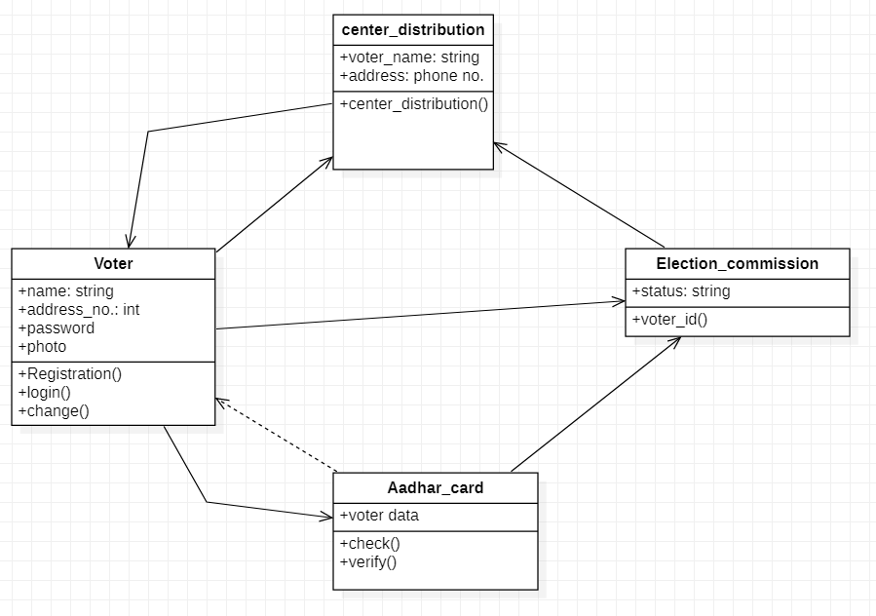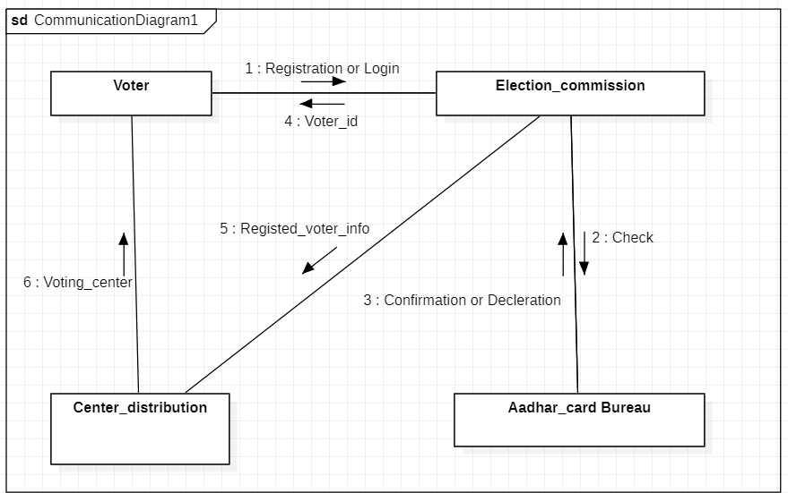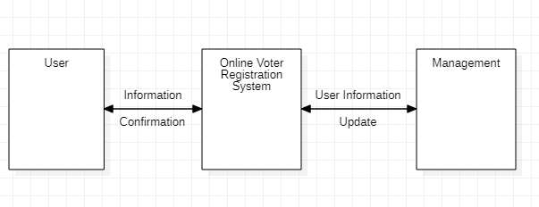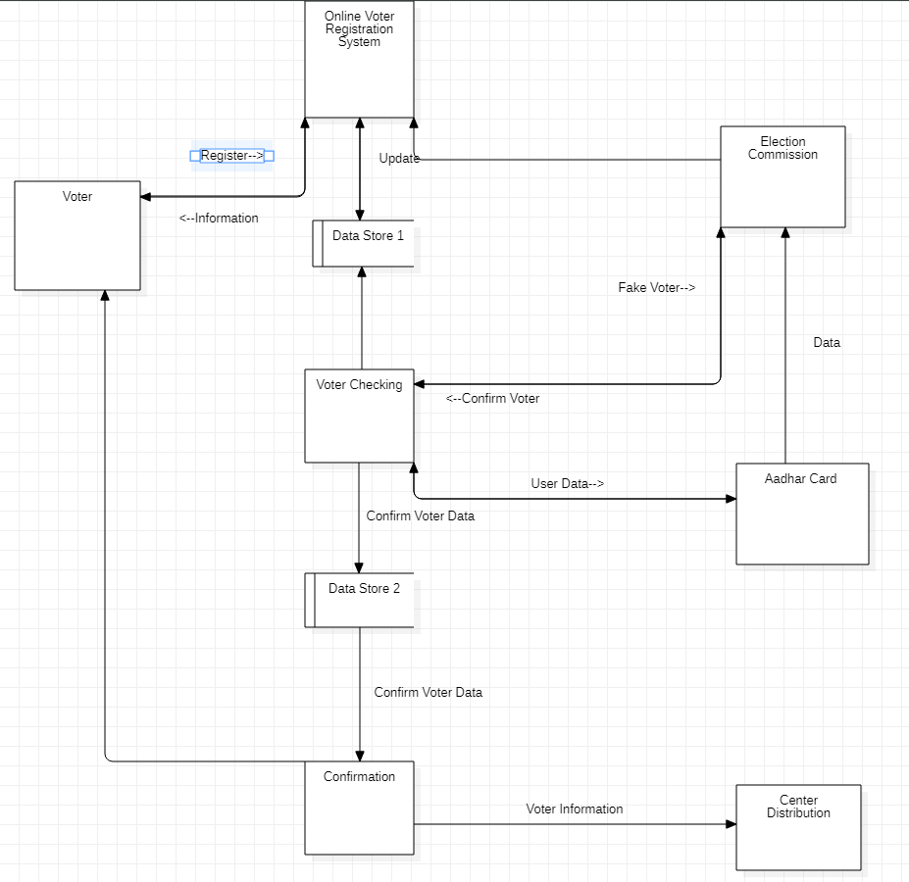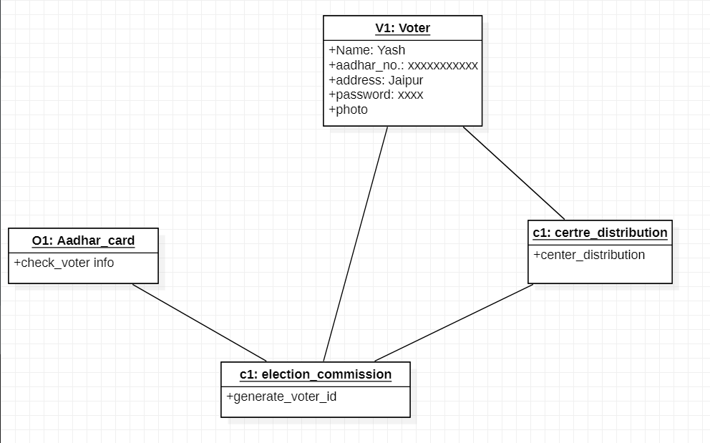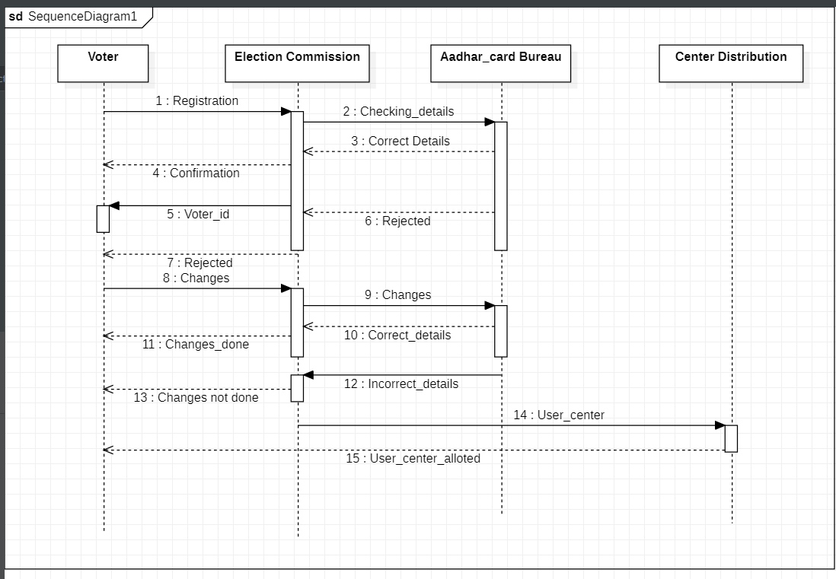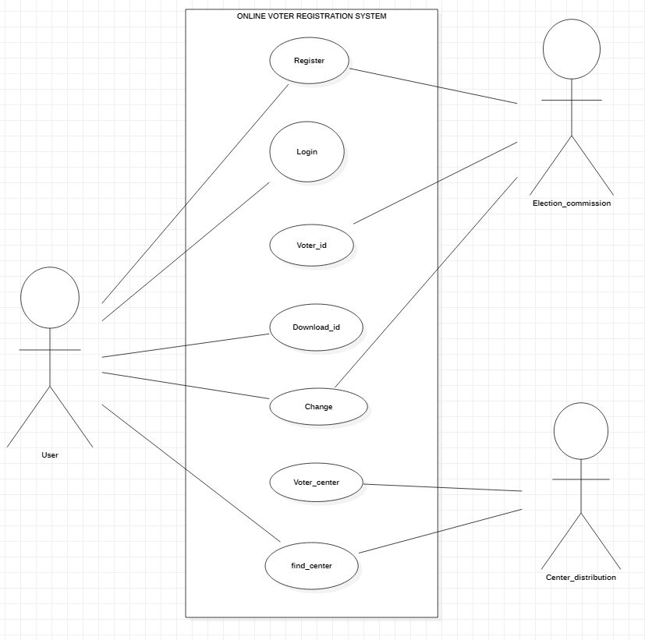

**Chapter 4: Conclusion**

In this we have identified the need for systematically producing a complete set of requirements specification for electronic voting systems that unifies the requirements imposed, the functionality reflected by the conventional voting procedures, and the required security attributes that the system should exhibit. We have applied a software engineering methodology for elicitating user requirements specification in a widely accepted format. This has been accomplished through a set of use cases, along with supplementary specifications. We have, thus, conceptualised an e-voting system in its entity, in a way that confines the number of possible subsequent designs, yet does not dictate a particular one.

This requirements specification is the outcome of the first “iteration” of the requirements elicitation process. We are currently validating and enhancing these requirements focusing, also, on non-functional ones and expect to incorporate the outcome of these activities in the system design and development phases.

**Chapter 5: References**

* Internet Policy Institute, Report of the National Workshop on Internet Voting: Issues and Research Agenda
* Research Agenda, March 2001, available at

http://www.internetpolicy.org/research/e_voting_report.pdf

* California Secretary of State B. Jones, A Report on the Feasibility of Internet Voting,

January, 2000 available at http://www.ss.ca.gov/executive/ivote/

* CyberVote (IST-1999-20338) project, Report on electronic democracy projects, legal
* issues of Internet voting and users requirements analysis, public deliverable, available at

http://www.eucybervote.org

* Jacobson I., Booch G., Rumbaugh J., The Unified Software Development Process, 1999, Addison Wesley.
* Addison Wesley.
* Jacobson I., Object-oriented software engineering - A use case driven approach, Addison-Wesley, 1993.
* Larman G., Applying UML and patterns, Prentice-Hall 1998.
* Jacobson I., Booch G., Rumbaugh J., The Unified Modelling Language User Guide, Addison-Wesley 1999, pp 457.

**Chapter 6: Snapshots of Project**

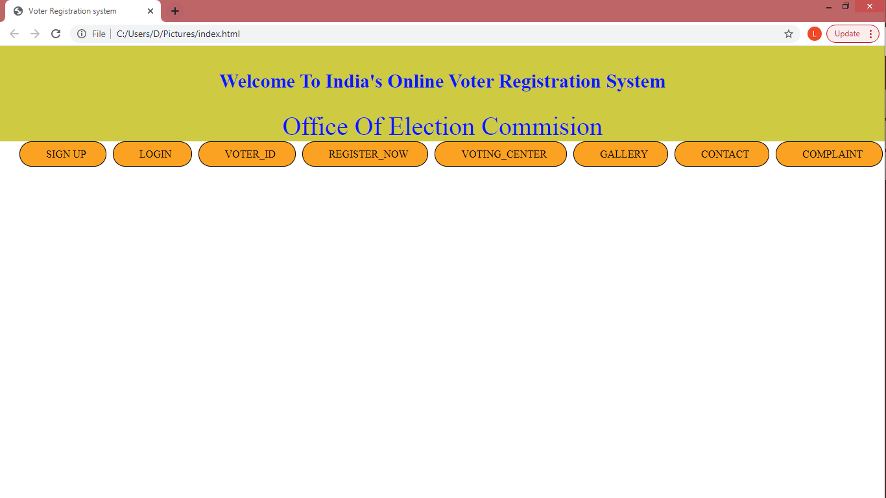

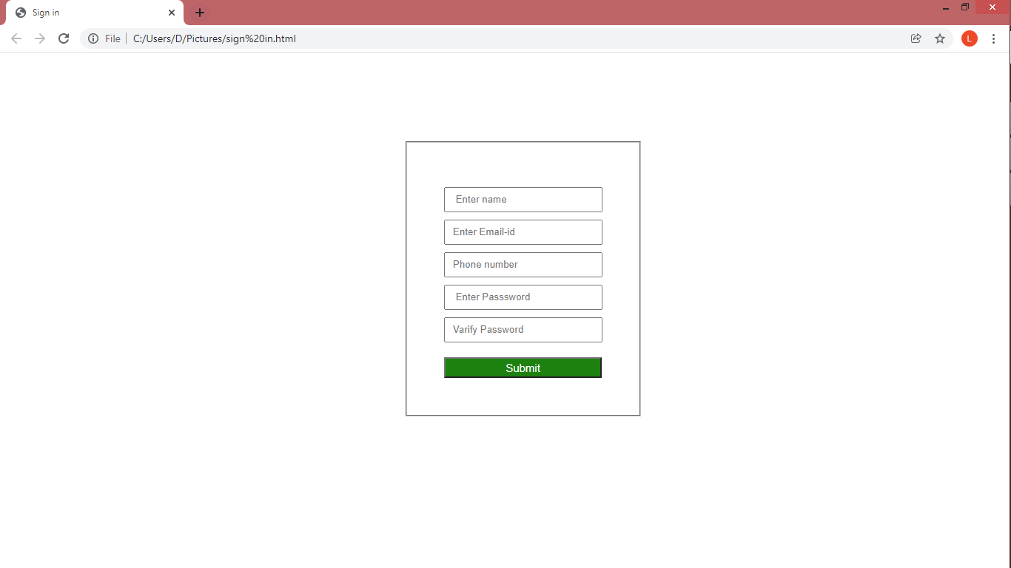

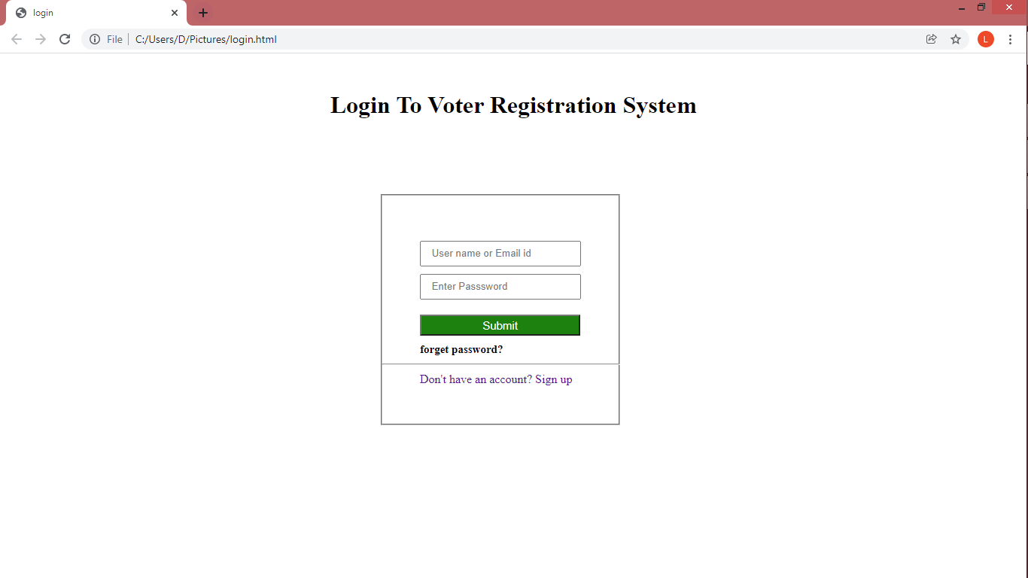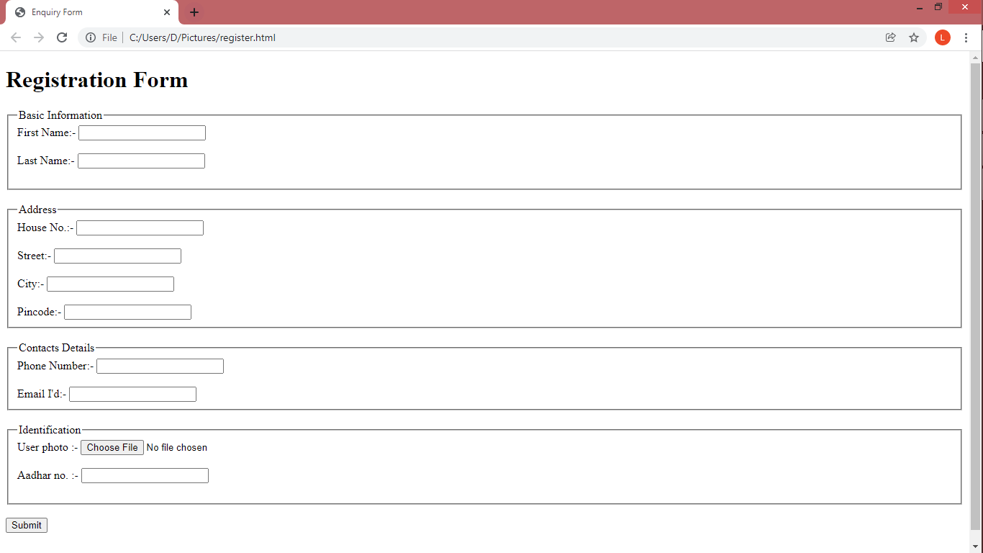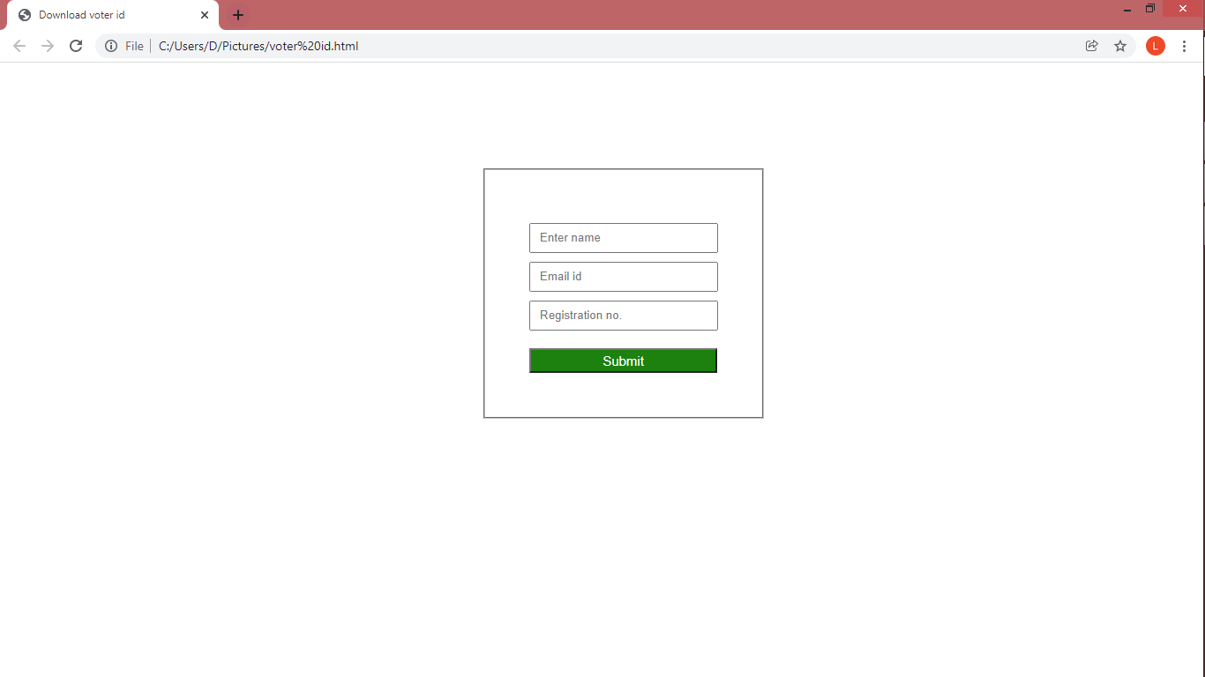

**Chapter 7: Code (Sample)**

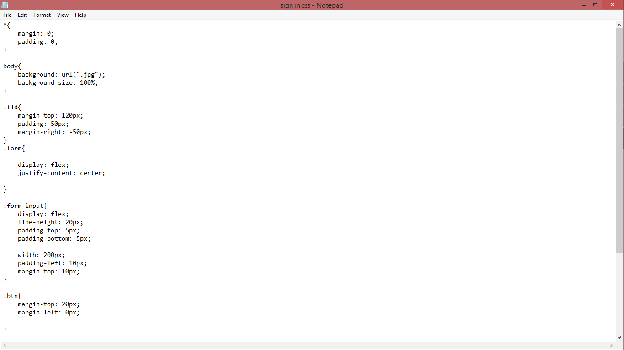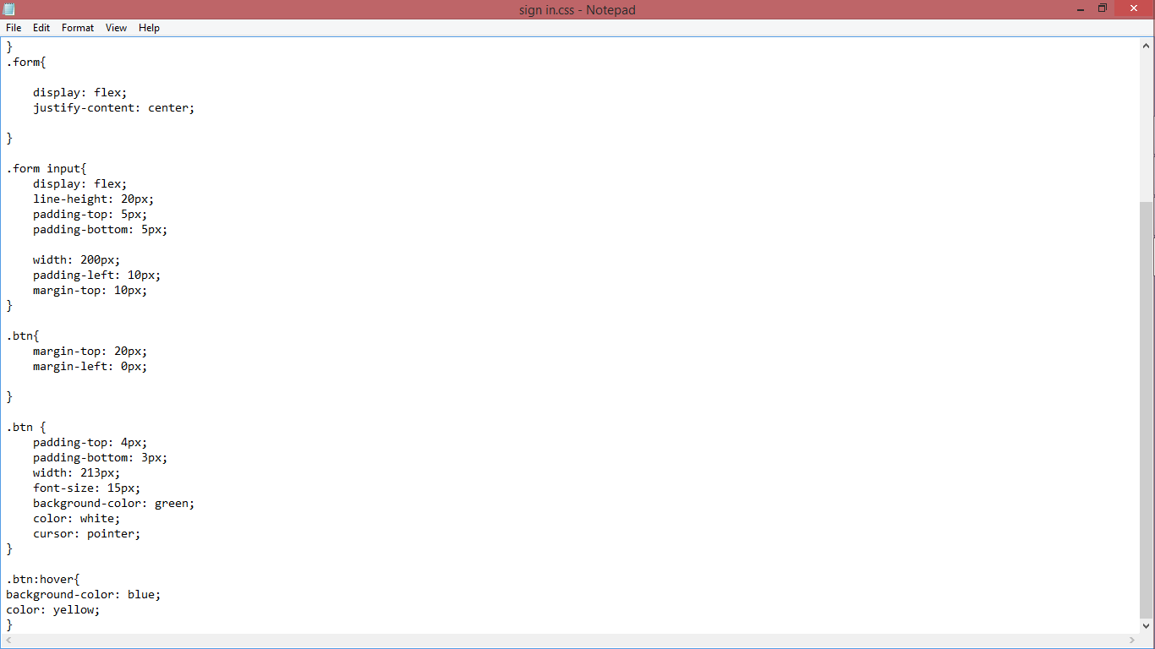

**DECLARATION**

I hereby declare that the Non syllabus Project report entitled ONLINE VOTER REGISTRATION SYSTEM was carried out and written by me under the guidance of PUNIT KUMAWAT, Assistant Professor, Department of Computer Engineering, Poornima Institute of Engineering & Technology, Jaipur. This work has not been previously formed the basis for the award of any degree or diploma or certificate nor has been submitted elsewhere for the award of any degree or diploma.

PGI PULKIT MITTAL

06/12/21 (PGI20AD010)